Meta Description:
In this blog, we will cover what is Twitter Marketing, its components, placement types, importance, tools, and how to create effective strategies.
Images:
https://drive.google.com/drive/folders/1safgVsk5eTe7i-dfZh3cROFaVgMw-IcG

What is Twitter Marketing & How to Do It in 2025?
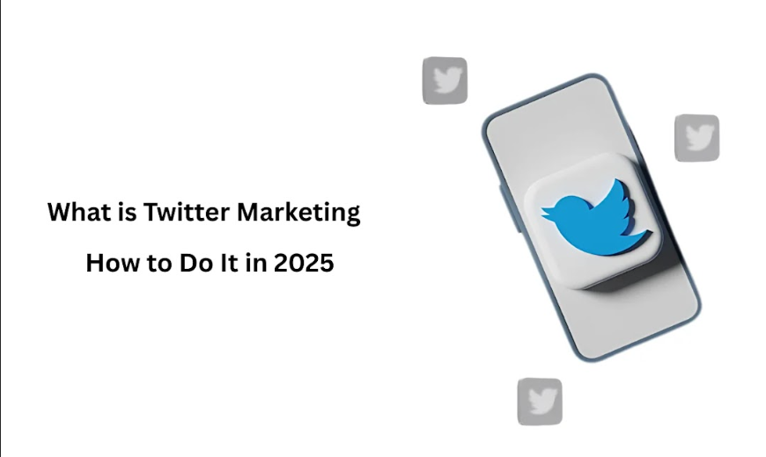
Twitter is one of the social media platforms that offer great opportunities to target the right audience effectively. Twitter is a very effective medium of real-time interaction between the brand and the customer base. It is essential to know everything about marketing on Twitter to survive in this environment.
In this blog, we shall discuss what Twitter marketing comprises, its fundamental subcomponents, ad specifications and placement types, and other tips we recommend for the best 2025 Twitter marketing strategy.

What is Twitter Marketing?
It is a deliberate plan with specific objectives of utilizing Twitter in the process of promoting businesses and brands and appealing to consumers. Twitter provides great opportunities for companies to engage with the target audience, follow the trends, and create a discussion around the brand. There are certain ways to use Twitter for marketing that translate to successfully carrying out the objective such as content production, communication, and analysis. The objective of these ways is to increase brand awareness, attract visitors to the website, create new business opportunities, and acquire customers.
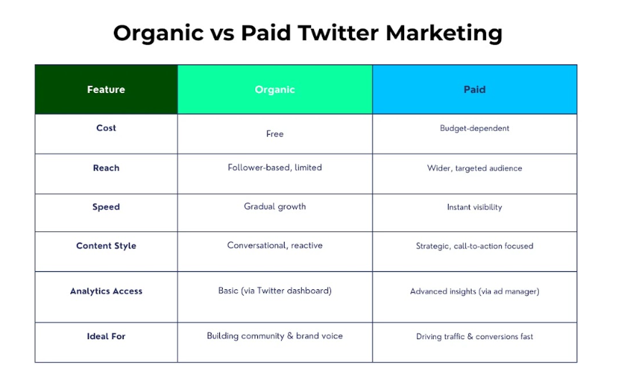

Key Components of Twitter Marketing
Let’s have a look at the key components of Twitter Marketing so you understand its significance and functions very well.
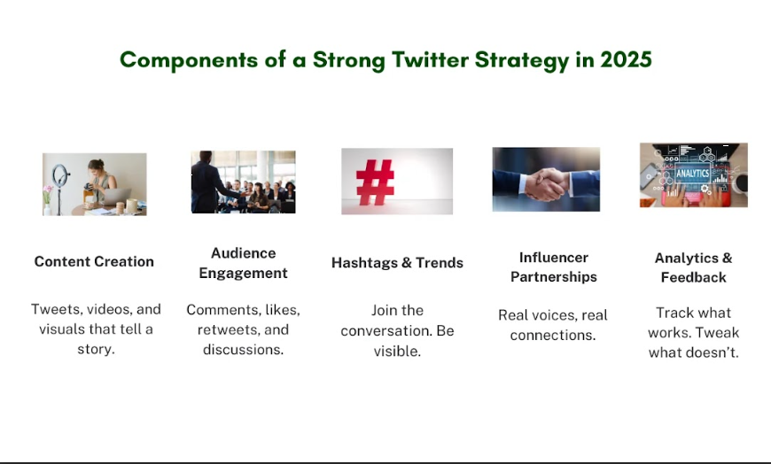

1. Content Creation
The main focus of marketing through Twitter is on content generation. By the year 2025, it is expected that text, famous images, or videos integrated with live tweets will be common feeds. Visual content in general and short videos, in particular, will continue serving well as attention magnets. So, as a marketer, you need to ensure that you create quality and relevant content that will be useful to your audience.

2. Engagement
It is very important to engage a lot of customers to have a proper representation of the social tool. This entails a process of reacting to some posts, sharing trending items, and contributing to the trend discussions. It will also be longer and more personalized in 2025. You can handle audience engagement through analytics, to favor brands that are more inclined to treat them in a way they consider favorable.

3. Hashtags and Trends
Hashtags and trends can be highly effective in improving the utility of the blog and attention on Twitter. The major idea of how brands can employ the use of hashtags is that it allows them to be a part of a bigger conversation. In the year 2025, an increased focus on the usage of branded hashtags is expected to occur to measure the results of the campaign as well as build a community around specific issues.

4. Influencer Collaboration
Marketers and businesspeople will continue to focus on influencer marketing in the utilization of Twitter as the primary social media platform. Influencer Collaboration enables the brands to reach their intended customers by leveraging on the community populaces. In 2025, micro-influencers will be relied on due to the nearness that they have over their audiences. It will create sustainable relationships between the company and an influencer to foster big value in the market.

5. Analytics and Measurement
You should utilize metrics to evaluate the performance of your marketing efforts on Twitter. Some of the major trends that will be observed in 2025 include added depth in analytic insights into the audience and campaigns. These perceptions will help brands arrive at intelligent decisions when posting content and interacting with netizens on social networks.

Available Placement Types Must Adopt in 2025:
As we approach the new year 2025, it is relevant to know about the ad specs and placement types to get the best out of your Twitter marketing strategy.
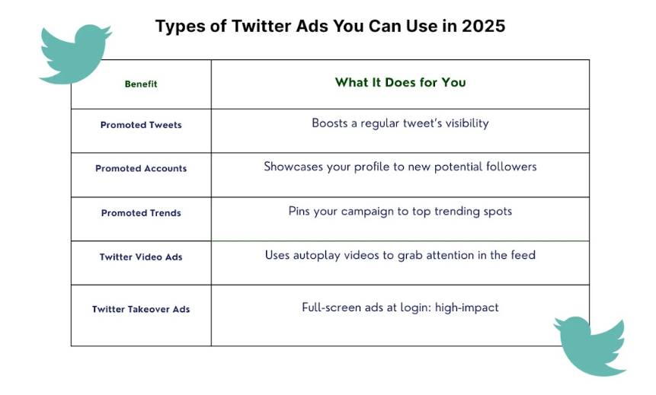

1. Promoted Tweets
Promoted Tweets are a specific advertisement form where the customer’s advertisement is posted on the user’s timeline in the same manner as any other tweet post. They could be text, images, videos, or links that can either be manufactured or created, bought, or modified. In 2025 social media websites will improve these ads to include other forms of interactive content including polls and quizzes. Marketers will have to aim at generating content that will make people want to click and share the content with others.

2. Promoted Accounts
Promoted Accounts also enable a brand’s profile to be posted on sections that a user may not be following, to reach that user. Such ads permit to specification of the profile image, name, and bio of the brand, as well as the individual heading. Daily, customers are also pampered by new possibilities. In 2025, brands can expect additional opportunities for profile customization that will help to attract extra attention.

3. Promoted Trends
Promoted Trends are ads that are displayed at the top of the trends and state that the corporation meets the requirements of the advertiser. It assists brands in making their content more visible by linking it to a trending issue. In 2025, AI will play a role in promoting and targeting the Promoted Trends so that they will reach the maximum number of users. It is very important for brands to quickly adapt to any current event by taking advantage of this ad type.

4. Twitter Video Ads
Twitter Video Ads are another type of advertisement that is in the form of short videos that are incorporated into the users’ timelines. It is especially important for those who aim to grab the reader’s attention and make him/her engaged in the text. By 2025, features like mouse-over ads, clickable layers, and call-to-action buttons will be integrated into these ads. So, it is the right time for brands to focus on generating visually stimulating and idea-based videos that tell a certain story.

5. Twitter Takeover Ads
Twitter Takeover Ads are banner ads that are in the form of full-screen videos and popups when a user logs in or switches accounts. Such ads provide a great chance for the brands to give a powerful start. In 2025, these ads are expected to be more elaborate and sophisticated in terms of graphics as well as storytelling. This format is very useful in providing powerful communication that calls for a definite response from its target audience brands.

6. App Install Ads
App Install Ads are a type of advertisement that persuades consumers to download an application program on their smartphones. These are displayed in the users’ timelines and contain a ‘click here to read more’ button. Maybe in 2025, Twitter may expand these ads by infusing more information about the app features and utilities. They should therefore be keen on developing relevant advertisements that will market their apps for downloads.

7. Dynamic Ads
A lot of computer ads adapt the page content with the help of Dynamic Ads. They are useful in remarketing and targeting the users who have already shown interest in a certain brand. By 2025, this type of advertising will be further enhanced, especially for personal dynamic ads with the help of AI. Marketers can use these ads to build up these leads and convert them into customers.

Why is Twitter Marketing Important to Your Business?
Now, let’s understand the significance of Twitter Marketing for your business:
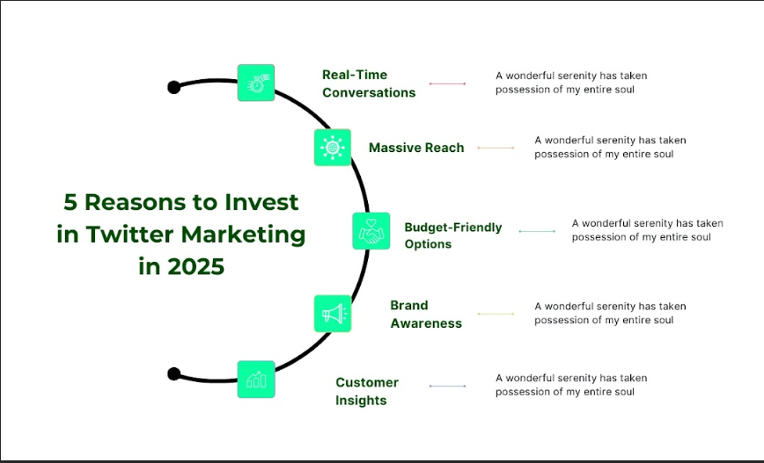

1. Real-Time Engagement
The last thing that makes Twitter outstanding is that it’s a social media site based on a real-time format. It enables businesses to interact with the audience on the social media platform in real-time. Through the use of this platform, you can respond to the customer’s questions, engage in conversations, or share important updates in real time. This immediacy fosters a sense of connection and trust between your brand and its followers.

2. Wide Reach and Visibility
Twitter has 650 million monthly active users and 240-300 million daily active users, given a massive market for business organizations to harness. It ranks them according to relevance and interaction with the previous updates by extending the odds of your post's exposure to the public. Through the use of hashtags, mentions, and use of trending topics on Twitter, your tweets can be viewed by other different users, potential customers, or business partners.

3. Cost-Effective Marketing
In comparison to the other digital marketing mediums, Twitter can offer a relatively low cost of reach or to market your business. Despite the availability of the option of paid promotions, organic tweets always stay high so long as you use good posting strategies. By creating interesting and sharable content, Twitter has the potential to expand your brand reach at a relatively low cost.

4. Enhanced Brand Awareness
Frequent and continuous activity on Twitter is a good way to generate and sustain brand awareness. The way the content is posted makes it consistent and therefore constantly reminds the audience of your brand’s existence. This is very important for maintaining the relationships with the partners and for ensuring the continuous patronage of the brand.

5. Customer Feedback and Insights
Customers also consider Twitter as a source of feedback and information. By reading the discussion that contains your brand name and tracking certain hashtags, you can learn the sentiments of consumers. This kind of feedback loop helps customers and businesses to work in collaboration with each other and to make necessary adjustments that would help your business to better satisfy the needs of your customers.

How to Create a Twitter Strategy in 2025?
When we consider the future of Twitter marketing in 2025, it’s only reasonable to say that it will change because nothing stays the same due to the rapidly changing environment. Below are a few tips that should help you to build an effective and innovative Twitter strategy:
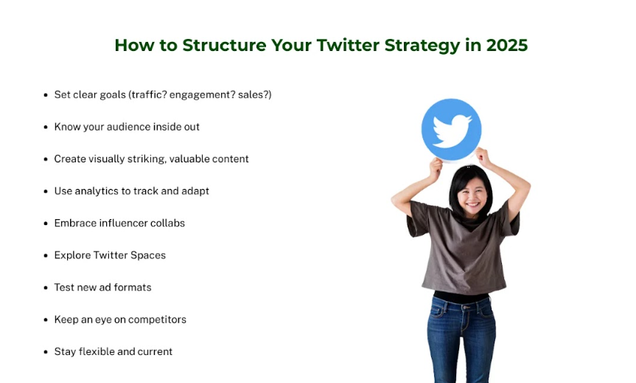

1. Define Your Objectives
First of all, it is necessary to state clear and achievable goals for your activity in the Twitter-sphere. Do you need to popularize your brand, attract more visitors to your website, find new clients, or make more sales?
Goals are an important aspect in determining the direction to follow, and how effectively the laid down strategies have been implemented. For example, if your goal is to enhance engagement, develop content that calls audiences to participate, for, instance, polls or questions.

2. Understand Your Audience
Understanding the target audience in 2025 will be even more significant than before. By using Twitter’s analytics tools, you can gather data or information on demographics, hobbies, and activity of the followers on Twitter. It will also enable you to create content that will suit their tastes and requirements. Furthermore, do not forget to observe the patterns as well as the ongoing discussions of your competitors and similar industries.

3. Craft Compelling Content
Content is still indeed king even in the context of the Twitter social networking application. The internet is only going to get more crowded by 2025, and the battle for people’s attention will be incredibly stiff. Concentrate on the simplicity and relevance of the content while choosing pictures that would be appealing to Twitter users. Turn to the combination of text, images, videos, and infographics to attract the audience’s attention. Use anecdotes when giving your information to make the audience easily relate to it. Just remember, all this is done to enrich the audience’s experience on Twitter.

4. Leverage Advanced Tools and Analytics
Over the years, with the advancement in technology, a lot of new ways have been created through which marketing can be done on Twitter. In 2025, advanced analytical tools shall be available to offer Twitter continued and more abstract analysis of performance. These are some of the tools that can be used to monitor aspects like the engagement rate, the reach, and the conversion rates. You can always use this data to fine-tune your strategy and make changes to the content that will generate better results.

5. Engage with Your Community
Building the community of your brand is vital for success in the long run. Build the essence of interaction with the audience through responding to comments and tweets, retweets, and tweeting. Express your gratitude to your followers for their support and embrace them for the feedback they offer you. By 2025, the realms of interaction and possible forms of the community within Twitter may be different from what you envision today.

6. Optimize for New Features
As with every Social Networking Site Twitter is active in incorporating new aspects and usability into the site. It is quite important to know about these changes and adjust to them if needed. For instance, if new options like advanced multimedia options or improved analytics are identified on Twitter it is important to include them in the content strategy to remain relevant.

7. Utilize Influencer Partnerships
Influencer marketing constantly remains relevant on Twitter. According to the research, the next decade may witness more profound changes to the stereotyped view of advertising with an element of Advertising that focuses on genuine relations between brands and influencers.

8. Plan for Paid Promotions
Although it is good to post items to status and be seen by your friends and followers, you can buy publicity to maximize your reach to those interested parties. The advertising options that will be available on the Twitter platform may be even more sophisticated in terms of target market identification and evaluation. Determine the amount of money to be spent in the paid promotions section and trial various styles of advertisements to determine their effectiveness.

9. Monitor and Adjust
Bear in mind that Twitter marketing is a continuous process. To manage your social media strategy, strive to assess the strengths, weaknesses, opportunities, and threats at the lowest and highest levels of the organization based on the time factor of analysis. Prepare to shift strategies that come out of the insights and fluctuations in the platform. This is why the practice of Twitter marketing has to be flexible and adaptable to survive in the quickly changing global market.

10. Stay Informed and Adapt
There is always something new popping in the digital horizon that’s why it is important for a marketer to update themselves often on what is current in the market. In 2025 and beyond, there will be new policies or features that may be added to Twitter or even changes to the algorithm that may affect your strategy. Be prepared to make changes and stick closely to the principle of maintaining the effectiveness of your Twitter marketing.

9 Pro Twitter Marketing Tips for 2025
Below are ten ideas to help your Twitter marketing turn heads come the year 2025:

1. Embrace Video Content:
The utilization of videos in your Twitter marketing deserves significant attention as more and more individuals turn to videos. Informational yet very short videos can create awareness and gain the audience’s attention. Take advantage of live streaming on Twitter to ensure the engagement of your audience in the course of the event.

2. Leverage Twitter Spaces:
Twitter Spaces, the latest set of extensions to the micro-blogging platform, allows new methods of interaction with users. Organize a Q&A session, an interview, or a live discussion as it is an effective way to communicate with the audience and increase your brand awareness among the target audience in the niche.

3. Utilize Twitter Analytics
Destination analysis and content performance measurement are very important. Twitter Analytics shows the details about the followers, the number of impressions of the tweets, and engagement ratios. Bring this information to the tactics and design your content that would be interesting to the target audience.

4. Engage with Trending Topics
You can achieve high relevance by actively engaging with your followers on trending topics. Hashtags and keywords will make it easy to connect you to the flow of a given conversation and make your suggestions memorable. However, try to avoid copying information from other sources and make sure the information that is provided is useful for the discussions.

5. Optimize Your Profile
Your Twitter account is the first thing any visitor or follower is likely to interact with from your brand. The picture should be clear and relevant, the bio brief and to the point with a hyperlink to your website. Make your handle catchy as well as related to your brand.

6. Schedule Your Tweets
The most valuable tip related to marketing on the Twitter platform is consistency. The promotion of a business on Twitter can be achieved by scheduling the tweets that are usually posted to ensure that there is a continuous flow of tweets even when the owner of the account is not active online. Determine the peak days and time to post to gain the highest level of engagement.
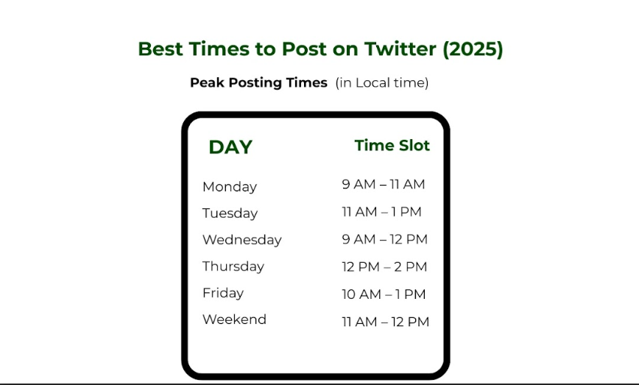

7. Foster Engagement
Engagement is a two-way street. It is also important to reply to mentions, retweets, and comments promptly. Twitter is the most important tool to ask questions to your followers, and get their feedback through polls and hosting of competitions.

8. Experiment with New Features
Twitter frequently introduces new features. However, it is always important to try them and see which ones are well-received by your target population. Adopting early puts an organization a step ahead of the other organizations that are planning to adopt BSC.

9. Monitor Competitors
To more extent possible, monitor your competitors’ activities and their strategies by implementing Twitter promotion techniques. You need to evaluate the content, the strategies used to engage the audience, and the followership they have gained. To adopt successful strategies and not repeat the mistakes made by the competitors.

Tools for Twitter Marketing: Paid & Free
When it comes to the implementation of your boosting strategies in the social platform of Twitter, the use of the right tools is very important. Below are the paid and free tool suggestions for sure:

Paid Tools:
- Hootsuite: An all-inclusive social media tool that can be used to post tweets, and monitor social media streams.
- Sprout Social: It has good analyzing, monitoring, and programming functions for the comfortable management of Twitter promotion.
- TweetDeck: A tool that gives real-time update options together with multiple organization of Twitter accounts, scheduling of tweets, and effects showing those tags.

Free Tools:
- Twitter Analytics: This tool is located inside the functionalities of the Twitter platform and offers user-specific information about the activity as well as the audience that they target.
- TweetReach: Another Twitter application that you can use for free to know the number of impressions that your tweets and hashtags are getting.
- Buffer: There is a free version where you can write posts and schedule tweets as well as gain post-engagement statistics.
- TweetBinder: A simple application that is used for tracking hashtags and participating in related Twitter conversations and also it is free.
- This Platform: Provides a breakdown and comprehensive analysis of general and specific activity on the Twitter account as well as a record of followers.

Ending Note:
From the above tips and tools, we hope you master well all Twitter strategies to succeed in the ever-growing interactive marketing in 2025. As a final note, it’s important to stress that users come first, as well as seeking to constantly create interesting and versatile posts based on new features. When in the right hands, From properly developed content, and ads, to appropriate engagement, Twitter is filled with potential interaction opportunities brands need to seize for them to grow.
For more information related to Twitter Marketing, you can consult with the Three Angle Marketing team to discuss your needs.

